1. Introduction

The data challenge topic covered in this report is 100 Years of Encyclopaedia Britannica, based on data provided by the National Library of Scotland. The data set included substantial text files that were combined into eight text files for convenience, according to the first eight editions of the encyclopaedia.

We chose to focus on the first Industrial Revolution, which occurred in England between 1750-1760 and lasted until 1820-1840 (Mohajan, 2019). However, the vast and extensive range of texts and information in the Encyclopaedia Britannica means that it is difficult for people to locate and read about specific topics of interest. By visualising a vivid story regarding the rapid growth of manufacturing and related technologies during the first Industrial Revolution, as well as its impact on the daily lives of people at that time, transgresses this topic from the ordinary nature of books and revitalises them. Encyclopaedias depict the democratisation of knowledge; therefore, it would be meaningful to create an immersive method of storytelling to demonstrate the information in encyclopaedias, as opposed to the standard book format.

2. Methodology

2.1 Data processing

Firstly, files of the same edition were manually merged through an online TXT file merger, whilst repetitive or unnecessary files were deleted. Following this consolidation, eight large TXT files remained of each edition of Encyclopaedia Britannica. Subsequently, the frequency of words relating to four topics indicating turning points in the history of the first Industrial Revolution was analysed. These topics were: energy and minerals, machines, living, and negative influences. To achieve a visual analysis of the changing keyword frequency in different encyclopaedia editions, coding was conducted to clean the textual data, followed by a frequency search. The output results were transferred to a data frame or comma-separated values (CSV) file for visualisation. After noticing that the frequency of words in each edition was increasing, the concept of word frequency was modified to the proportion of words per billion words to ensure a more reliable analysis.

2.1 Virtual reality

To create a more immersive environment that varies significantly from simple texts, alternative forms of visualisation were considered, such as two-dimensional (2D) or three-dimensional (3D) games. However, this report regarded virtual reality (VR) as superior because it provides an experience of a world deemed completely fictional. These virtual worlds are often far more absorbing than other types of media and provide simulated experiences that engage users in context-relevant behaviours. Resultantly, a variety of user experiences are established depending on the chosen VR environment (Pericles, 2018).

Unity was selected as the platform to develop this game. To build the game scene, 3D modelling was used to create a city during the first Industrial Revolution, whereby players could walk around and explore (Figure 1). Signs relevant to this historical period were included in the city, such as “steam engine” and “steam ships”.

Figure 1. The architecture of the Industrial Revolution period

Concurrently, smoke and fog were included in the city to reflect the environmental pollution prevalent at the time. Various corresponding animations and sounds were also included in the scene. Players can simulate residents walking along the street and can interact with cue signs in the area by touching, observing, or picking up actions to unlock the corresponding animation.

Once the scene model was complete, the connection with VR was finalised in Unity. An asset called VIVE Input Utility was used, which supports VR helmets by brands such as HTC and Oculus, and determined the conditions through the code. When the conditions are met, the animations are triggered.

Results

3.1 Energy and machines

For energy and minerals, coal, copper, iron, steel, and cement were chosen as keywords; for machines, the words machine, steam, ship, train, and spinner were chosen. Figure 2 shows that the proportion of iron and copper remained high throughout all eight editions, which was likely due to the substantial emergence of machines constructed from iron during the first Industrial Revolution. Replacing [wood](https://en.wikipedia.org/wiki/Wood) and other bio-fuels, coal played a vital role in the Industrial Revolution since engines were primarily fuelled by coal (Mohajan, 2019). The invention of the steam engine triggered the early modern industrial era, which led to revolutions in textiles, mines, steam-powered railroads, steam-powered ocean freighters, steel production, and other economic activities (Mohajan, 2019). Therefore, it was expected that the word machines would be prevalent; moreover, the proportion of the words steam and ship (Figure 3) reflects the surge of steam engines from 1820, which relates to edition 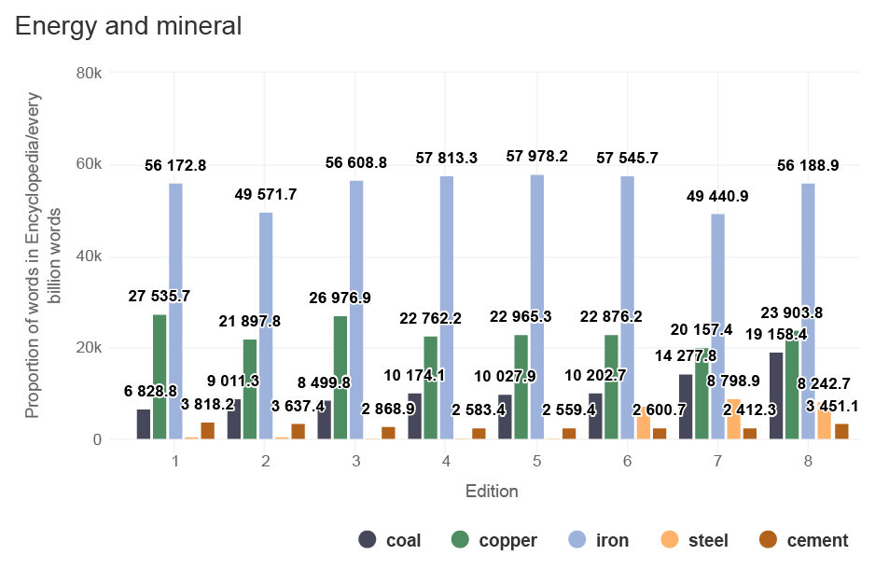six of the encyclopaedia.

Figure 2. The proportion of the selected keywords relating to energy and minerals per billion words in the Encyclopaedia Britannica

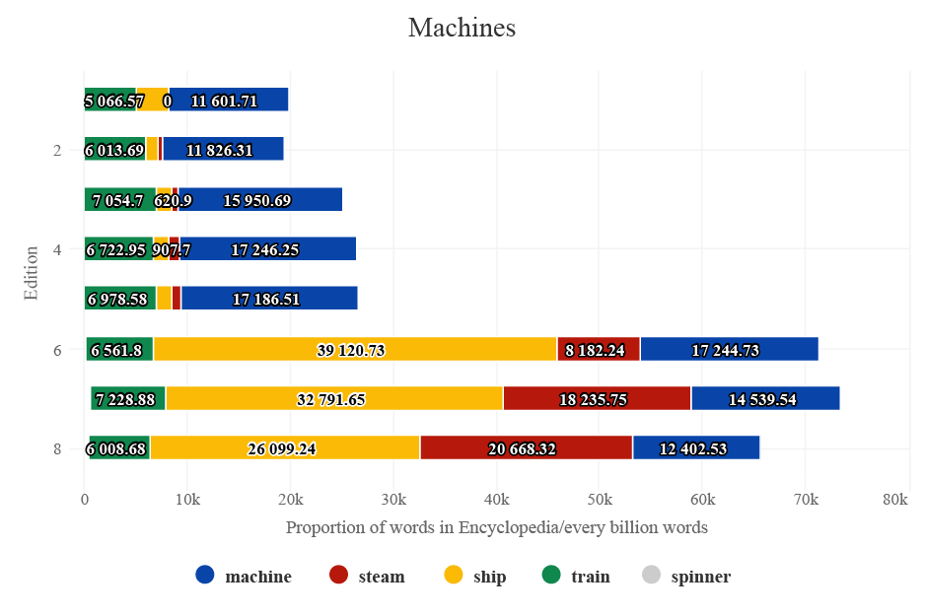

Figure 3. The proportion of the selected keywords relating to machines per billion words in the Encyclopaedia Britannica

3.2 Living and negative influences

The impact of the first Industrial Revolution was so significant that the lives of the public also changed drastically. A distinct surge of the proportion of the word house was observed in edition six, most likely due to modern industrial growth since the late 18th century resulting in [urbanisation](https://en.wikipedia.org/wiki/Urbanisation) and the rise of new cities and housing. Accordingly, the boom of manufacturing and industry resulted in employment changes - farmers often became factory workers. However, living conditions deteriorated, especially due to extensive fog and smoke issues. Unclean water and poor sanitary conditions caused many workers to suffer from an array of diseases, as depicted in Figure 5. Thus, it appears that the rapid development came with negative consequences.

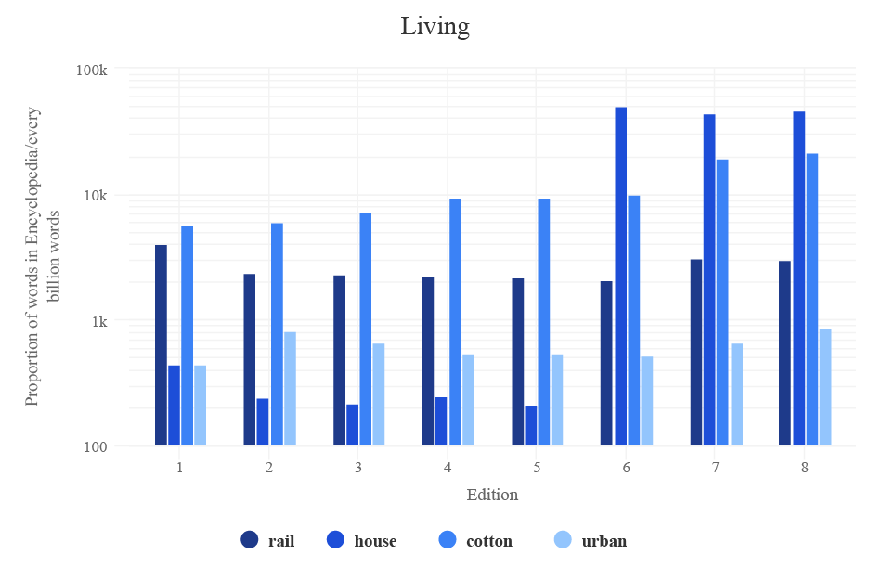

Figure 4. The proportion of the selected keywords relating to living per billion words in the Encyclopaedia Britannica

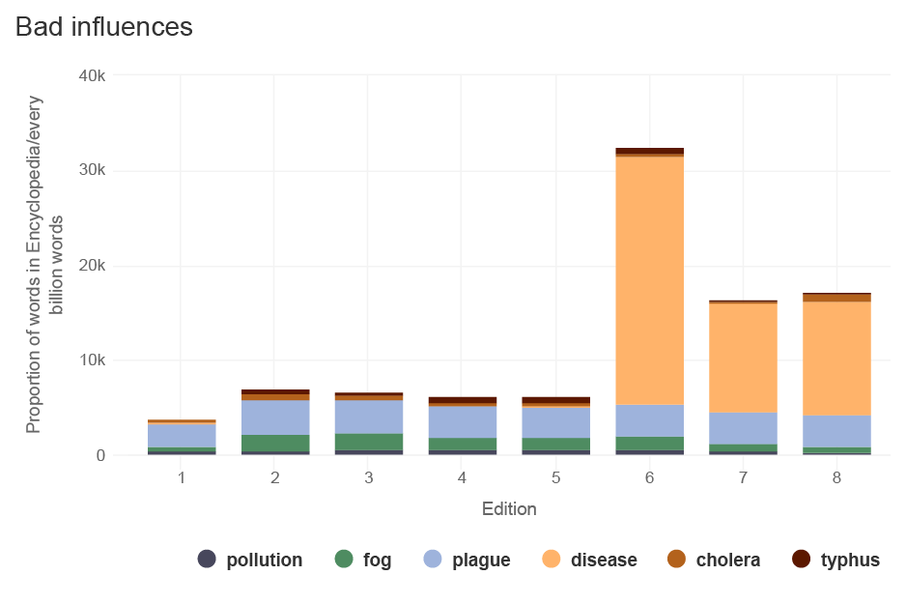Figure 5. The proportion of the selected keywords relating to negative influences per billion words in the Encyclopaedia Britannica

4. Conclusion

With the intention of demonstrating the pros and cons of the first Industrial Revolution and to prevent this history from being lost, our group designed a VR game that takes users to this time period to learn more about the related information provided in Encyclopaedia Britannica. Following an immersive journey, users can deepen their understanding of the Industrial Revolution by answering questions. Also, this VR game can be adapted to suit museums and libraries, where people could gain historical knowledge more easily. The limitation of VR games is that they can only be played by one person at a time, but the use of computer screens can show others what is happening in the game.

It is our hope that creating an immersive world of information can help history become more accessible and understandable to the public, just like the original intention of an encyclopaedia.

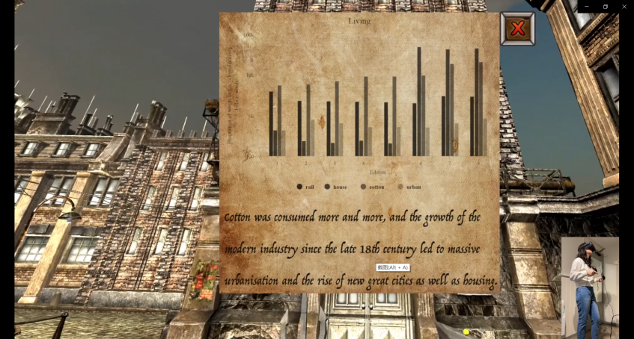

Video Link: https://vimeo.com/653638894

1. References

1.Mohajan, Haradhan. "The first industrial revolution: creation of a new global human era." (2019): 377-387.

2.Yildirim, Caglar, et al. "Video game user experience: to VR, or not to VR?." 2018 IEEE Games, Entertainment, Media Conference (GEM). IEEE, 2018.